Team id : PNT2022TMID07659

Project Milestone & Activity Planning:

Milestone:

Modern Technology are increasing and optimizing the Performance of the Artificial Intelligences (AI) Model.Based Crop Yield Disease Prediction System, is helpful for farmers to prevent the crop from the various Disease whichcan identify the Disease with in a process of capturing the Image at the plant and Machine Learning Algorithm will giveaffected Disease Name.

In this Project Milestone will be given the Best Solution for the farmer using the complete friendly and simple user interface web application to fetching the solution by own.

In addition, process we are planned to add a valid Module that is Fertilizer recommendation for the Specific Disease. It can give both Artificial fertilizer and Natural Fertilizer in suggestion manner.



Activity List:

In Project Management Planning is an Important task to scheduling the phrase of the project to the Team Member.

In this Activity can shows the various activity are allocated and Done by the Team Members!

In Project we can Split into the Four Step of Phrases are

Phrase 1: Information Collection and Requirement Analysis

Phrase 2: Project Planning and Developing Modules

Phrase 3: Implementing the High Accuracy Deep Learning Algorithm to Perform

Phrase 4: Deploying the Model on Cloud and Testing the Model and UI Performance

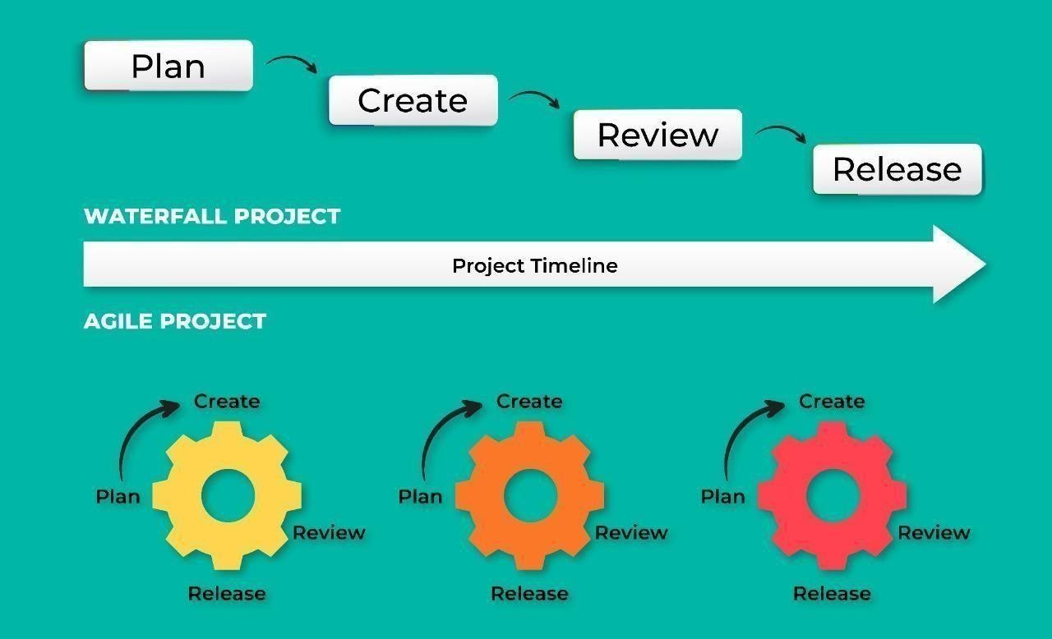

Agile Methodology for Activity Planning